NHT-200

2-jaw and 3-jaw through-hole power chuck (adapter included)
- Gripping of round or irregular workpiece does not need to change the chuck.
- The chucks are designed according to ASA B5.9 type A spindle.
- The chucks are made from high grade alloy steel. All sliding surfaces are hardened and ground to increase running accuracy and longer service life.
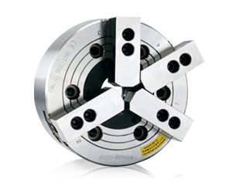
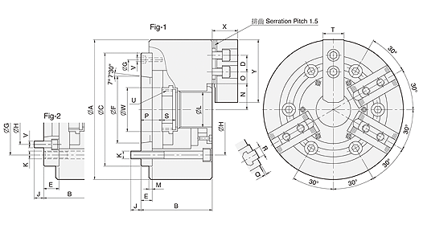
UNIT : mm
SPEC  Model | Through  -Hole  (mm) | Plunger  Stroke  (mm) | Jaw  Stroke  (In Dia.)  (mm) | Max. Pull Force  (kgf)  3 Jaw / 2 Jaw | Max. Gripping Force  (kgf)  3 Jaw / 2 Jaw | Max. Operating  Pressure  (kgf / cm²)  3 Jaw / 2 Jaw | Max.  Speed  (r.p.m.) | Weight  (kg) | Matching  Cylinder | Matching  Hard Jaw | Matching  Soft Jaw
NHT-208A5 | Ø52 | 16 | 7.4 | 2243 / 1495 | 5812 / 3875 | 17.2 / 12.1 | 3500 | 25.2 | M1552 | HJ06 | HC08-1
NHT-208A6 | Ø52 | 16 | 7.4 | 2243 / 1495 | 5812 / 3875 | 17.2 / 12.1 | 3500 | 24.7 | M1552 | HJ06 | HC08-1

DIM  Model | A | B | C  (H6) | D | E | F | G | H | J | K | L | M | N  max. | O  max. | O  min. | P  max. | P  min. | Q | R | S | T | U  max. | V | W | X | Y | Referenoe
NHT-208A5 | 210 | 113 | 170 | 20 | 23 | 82.563 | 133.35 | 104.78 | 13 | 6xM12 | 52 | 5 | 41.8 | 34 | 7.5 | 37.5 | 21.5 | 2 | 12 | 20.5 | 35 | M60x2 | 6xM10 | 66 | 37 | 73 | Fig-2
NHT-208A6 | 210 | 107 | 170 | 20 | 17 | 106.375 | 150 | 133.35 | 17 | 6xM12 | 52 | 5 | 41.8 | 34 | 7.5 | 31.5 | 15.5 | 2 | 12 | 20.5 | 35 | M60x2 | 3xM6 | 66 | 37 | 73 | Fig-1

