SC

3-jaw scroll chuck plain back, solid jaws (front and back mounted)
- Interchangable utilization of internal and external hard jaws.
- SC types feature economical and durable, suitable for mass production.
- Gripping accuracy of 0.03mm (0.0012 inch) T.I.R..
- The body is made of MEEHANITE. It is suitably used for high speed revolution and 3 times more durable than regular material.
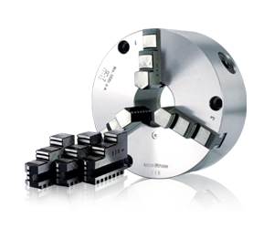
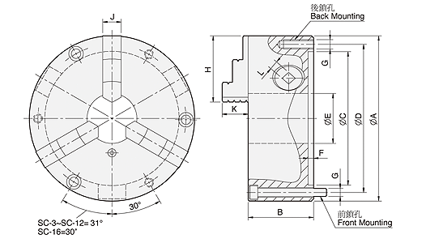
UNIT : mm
SPEC  Model | A | B | C | D | E | F | G | H | J | K | L | Allowable  Handle  Torque  (kgf‧m) | Gripping  Force  (kgf) | Max.  Speed  (r.p.m.) | Weight  (kg) | Moment  Of Inertia I  (kg‧m² ) | Gripping Range
 |  |  |  |  |  |  | Back / Front |  |  |  |  |  |  |  |  |  | O.D. Range / I.D. Range
SC-3 | 86 | 46 | 60 | 73 | 16 | 4.1 | 3-M6 / 3-M6×50 | 36 | 11 | 14.3 | 7 | 3.0 | 900 | 2500 | 1.7 | - | Ø2-Ø70 / Ø24-Ø6
SC-4 | 112 | 60 | 80 | 95 | 24 | 4.8 | 3-M8 / 3-M8×70 | 42 | 14 | 16.6 | 8 | 4.5 | 1200 | 2500 | 3.7 | - | Ø3-Ø95 / Ø29-Ø84
SC-5 | 132 | 60 | 100 | 115 | 32 | 4.8 | 3-M8 / 3-M8×70 | 50 | 16 | 20.3 | 8 | 6.5 | 1500 | 2500 | 5.2 | 0.01 | Ø3-Ø110 / Ø33-Ø100
SC-6 | 167 | 67 | 130 | 147 | 45 | 5.5 | 3-M10 / 3-M10×70 | 63 | 19 | 23.7 | 10 | 9.0 | 2200 | 2000 | 9.3 | 0.03 | Ø4-Ø160 / Ø48-Ø150
SC-7 | 192 | 76.5 | 155 | 172 | 58 | 5.5 | 3-M10 / 3-M10×80 | 77 | 21.5 | 29.4 | 11 | 11.0 | 2500 | 2000 | 14.2 | 0.06 | Ø4-Ø180 / Ø56-Ø170
SC-8 | 200 | 76.5 | 160 | 176 | 58 | 5.5 | 3-M10 / 3-M10×80 | 77 | 21.5 | 29.4 | 11 | 11.0 | 2500 | 2000 | 16 | 0.07 | Ø4-Ø190 / Ø62-Ø180
SC-9 | 232 | 84 | 190 | 210 | 70 | 6 | 3-M12 / 3-M12×90 | 87 | 24 | 35.6 | 12 | 15.0 | 3000 | 2000 | 22.7 | 0.15 | Ø5-Ø220 / Ø62-Ø210
SC-10 | 273 | 87 | 230 | 250 | 89 | 8 | 3-M12 / 3-M12×90 | 98 | 28 | 39.5 | 12 | 19.5 | 4000 | 1800 | 31.8 | 0.25 | Ø6-Ø260 / Ø70-Ø2
SC-12 | 310 | 96 | 260 | 285 | 105 | 7 | 3-M12 / 3-M12×110 | 110 | 30 | 45.6 | 14 | 21.0 | 4200 | 1800 | 44.8 | 0.58 | Ø10-Ø300 / Ø86-Ø290
SC-16 | 405 | 122 | 345 | 375 | 160 | 8.7 | — / 6-M14×130 | 146 | 42 | 56.3 | 15 | 25.0 | 4500 | 1500 | 102 | 1.75 | Ø30-Ø380 / Ø110-Ø360

