SIK

4-jaw strong scroll chuck plain back, 2-piece jaws (front and back mounted)
- Hard jaws are adopted for square or octagonal thin tube workpieces machining.
- Soft jaws could grip rectangular workpiece after being unisotropic machined.
- The specification is the same as SK type.
- The body is made of MEEHANITE. It is suitably used for high speed revolution and 3 times more durable than regular material.

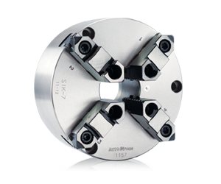
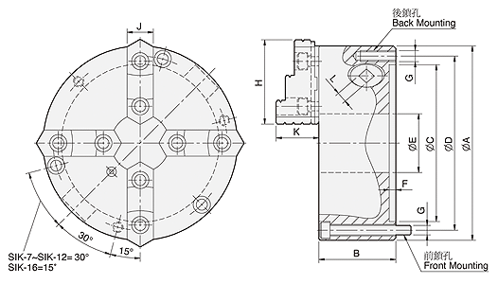
UNIT : mm
SPEC  Model | A | B | C | D | E | F | G | H | J | K | L | Allowable  Handle  Torque  (kgf‧m) | Gripping  Force  (kgf) | Max.  Speed  (r.p.m.) | Weight  (kg) | Moment  Of Inertia I  (kg‧m² ) | Gripping Range
 |  |  |  |  |  |  | Back / Front |  |  |  |  |  |  |  |  |  | O.D. Range / I.D. Range
SIK-7 | 192 | 76.5 | 155 | 172 | 58 | 5.5 | 3-M10 / 3-M10x80 | 82 | 28 | 42 | 11 | 11.0 | 2500 | 2000 | 14.1 | 0.06 | Ø8-Ø180 / Ø62-Ø170
SIK-9 | 232 | 84 | 190 | 210 | 70 | 6 | 3-M12 / 3-M12x90 | 96 | 32 | 51.2 | 12 | 15.0 | 3000 | 2000 | 22.2 | 0.16 | Ø11-Ø220 / Ø70-Ø210
SIK-12 | 310 | 96 | 260 | 285 | 105 | 7 | 3-M12 / 3-M12x110 | 114.5 | 40 | 56.8 | 14 | 21.0 | 4200 | 1800 | 45 | 0.58 | Ø15-Ø300 / Ø90-Ø290
SIK-16 | 405 | 122 | 345 | 375 | 160 | 8.7 | — / 6-M14x130 | 148.6 | 50 | 76.1 | 15 | 25.0 | 4500 | 1500 | 108 | 1.72 | Ø30-Ø380 / Ø110-Ø360

