HJ

Hard jaw for hydraulic power chuck
- Hard jaw for hydraulic power chucks.
- Hard jaw for CNC lathe.
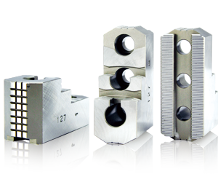
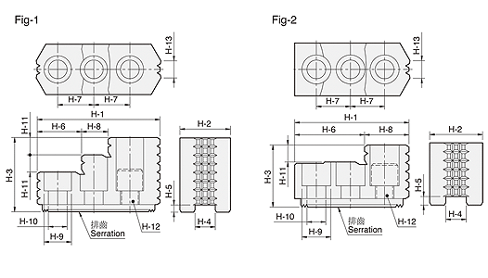
UNIT : mm
SPEC  Model | H-1 | H-2 | H-3 | H-4 | H-5 | H-6 | H-7 | H-8 | H-9 | H-10 | H-11 | H-12 | H-13 | Serration  Pitch | Reference | Matching  Chuck | 3 Jaw  Weight  (kg)
HJ05 | 53 | 23 | 27.5 | 10 | 4 | 30.5 | 14 | 22.5 | 13.5 | 8.5 | 10 | M8 | 6 | 1.5x60° | Fig-2 | N-204, N-205 | 0.4
HJ06 | 67 | 31 | 35 | 12 | 5 | 39.5 | 20 | 27.5 | 17 | 11 | 12 | M10 | 11 | 1.5x60° | Fig-2 | N-206, V-206 | 1.0
HJ08 | 86 | 35 | 51 | 14 | 5 | 31 | 25 | 18 | 19 | 13 | 12 | M12 | 12 | 1.5x60° | Fig-1 | N-208, V-208 | 1.9
HJ10 | 99.5 | 40 | 54 | 16 | 5 | 43 | 30 | 17 | 19 | 13 | 13 | M12 | 15 | 1.5x60° | Fig-1 | N-210, V-210 | 2.9
HJ12 | 103 | 50 | 52 | 21 | 4 | 62.5 | 30 | 40.5 | 25 | 17 | 17 | M16 | 30 | 1.5x60° | Fig-2 | N-212 | 3.5
HJ12-1 | 103 | 50 | 52 | 18 | 5 | 62.5 | 30 | 40.5 | 22 | 15 | 17 | M14 | 30 | 1.5x60° | Fig-2 | V-212 | 3.6
HJ15 | 149 | 62 | 86 | 22 | 8 | 63 | 43 | 34 | 32 | 21 | 20 | M20 | 40 | 1.5x60° | Fig-1 | N-215, N-218 | 9.6
HJ15-1 | 149 | 62 | 86 | 25.5 | 5 | 63 | 43 | 34 | 32 | 21 | 20 | M20 | 40 | 1.5x60° | Fig-1 | V-215, V-218 | 9.5
HJ24-1 | 159.5 | 80 | 90 | 25 | 9 | 104.5 | 50 | 55 | 32 | 21 | 40 | M20 | 55 | 3.0x60° | Fig-2 | N-220, N-224, N-232  V-221, V-224, V-232 | 14.3

