P165

Floating plate center chuck
- Suitable for easy one step cutting of thin hores, plate and outside diameter.
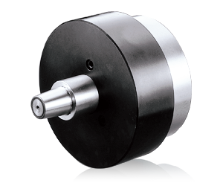
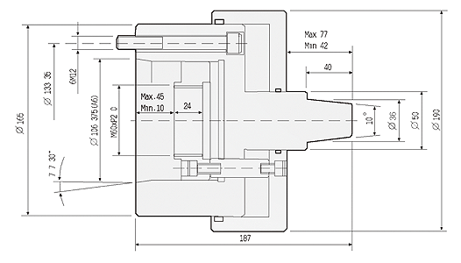
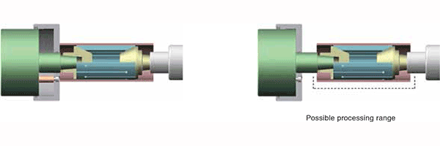
UNIT : mm
SPEC  Model | Plunger  Stroke  (mm) | Max.  Operating  Pressure  MPa(kgf/cm²) | Max.  Speed  (r.p.m.) | Weight  (kg) | Moment  Of Inertia  I  (kg‧m² ) | Matching  Cylinder
P165 | 35 | 1.0(10) | 6000 | 18.5 | 0.02 | MS125C35

