HB4

Boring mill jaw
- Clamping of workpiece for larger size lathe, vertical lathe, die set with jig.
- One set of 4-piece with T-bolt.
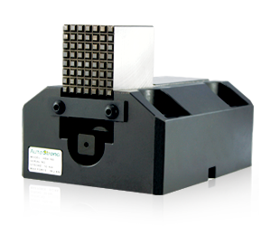
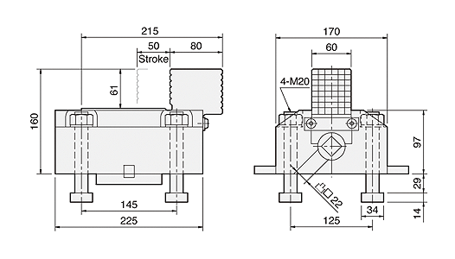
UNIT : mm
SPEC  Model | Jaw Stroke  (mm) | Max. Gripping Force  (kN) | Weight  (kg)
HB4-160 | 20 | 39.2 | 29
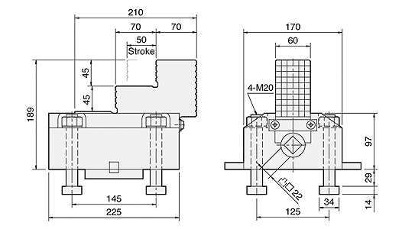
UNIT : mm
SPEC  Model | Jaw Stroke  (mm) | Max. Gripping Force  (kN) | Weight  (kg)
HB4-189 | 50 | 39.2 | 31
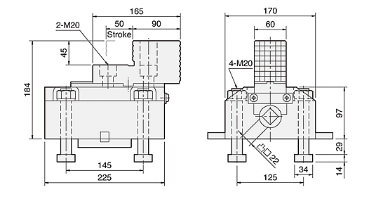
UNIT : mm
SPEC  Model | Jaw Stroke  (mm) | Max. Gripping Force  (kN) | Weight  (kg) | Matching Soft Jaw
HB4-2P | 50 | 39.2 | 31 | HE2486

