CR

Collet chuck for cylindrical center mount
- Collet chucks with bayonet catch are mainly used for chucking bar work on NC / CNC lathes.
- The bar can be fed in through the chuck.
- Profiles can also be chucked with the appropriate collets.
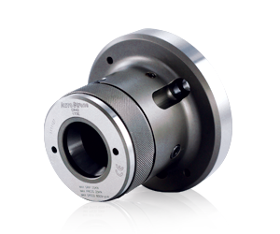
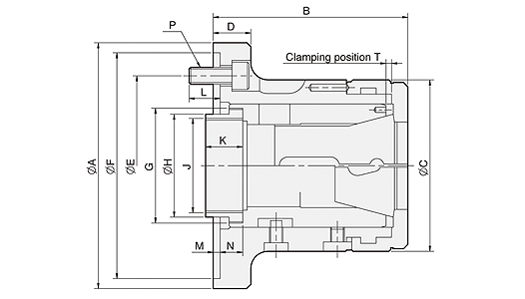
UNIT : mm
SPEC  Model | Matching  Adapter | Bar  Capacity  (mm) | Sleeve  Stroke  (mm) | Max.  Push  Force  KN(kgf) | Max.  Gripping  Force  KN(kgf) | Max.  Speed  (r.p.m.) | Weight  (kg)
CR42-140 | 140 | 42 | 7 | 25 (2549) | 55 (5608) | 6000 | 6.2
CR60-170 | 170 | 60 | 7 | 30 (3059) | 65 (6628) | 5000 | 11.5
CR60-220 | 220 | 60 | 7 | 30 (3059) | 65 (6628) | 5000 | 15.5

DIM  Model | A  (h6) | B | C | D | E | F  (h6) | G | H | J  max. | K | L | M | N | P | T
CR42-140 | 155 | 114 | 100 | 23 | 104.78 | 140 | M66xP1.5 | 60 | M55xP2.0 | 25 | 18 | 6 | 11.9 | 3-M10 | 3.1
CR60-170 | 185 | 139 | 130 | 30 | 133.35 | 170 | M90xP1.5 | 80 | M74xP2.0 | 30 | 18 | 6 | 17.9 | 6-M12 | 3.1
CR60-220 | 235 | 141 | 130 | 32 | 171.45 | 220 | M90xP1.5 | 80 | M74xP2.0 | 30 | 20 | 6 | 19.9 | 6-M16 | 3.1

Capacities  Chuck | MULTIBORE | SPRING COLLET
NO. | Cat.No. / ○ / / □ | Cat.No. / ○ / / □
CR42 | M-673 / 42 / 36 / 30 | 173E / 4728 / 42 / 36 / 30
CR60 | M-677 / 60 / 52 / 42 | 185E / 4291 / 60 / 52 / 42
*Uses the collet to DIN6343 specification.
